In situ battery characterization in the home lab – project thesis

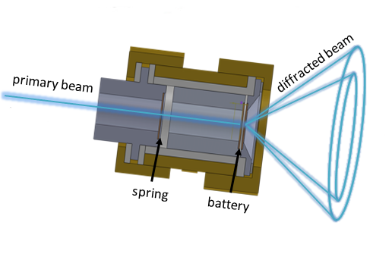
In a world with a growing demand for energy storage, for example for portable electronic devices and from renewable energy sources, batteries play a crucial role. To improve the
battery performances it is important to have an understanding of the structural evolution of
the battery electrodes during cycling of the battery, since the phase transitions for example
Figure 1: Sketch of the in situ cell with primary and diffracted beam
influences the kinetics and the voltage profile. It is of practical and economical importance
to be able to perform measurements at a home laboratory. Therefore an in situ setup making it possible to measure in situ x-ray diffraction data for battery materials has been developed.

The setup was developed using the well-known cathode material LiMn_{1.5}Ni_{0.5}O₄, comparing the home lab result with state-of-the-art synchrotron experiments¹. As seen from Fig. 2 it is in the case of the spinel possible to differentiate between three distinct phase as the cathode is de-/lithiated.
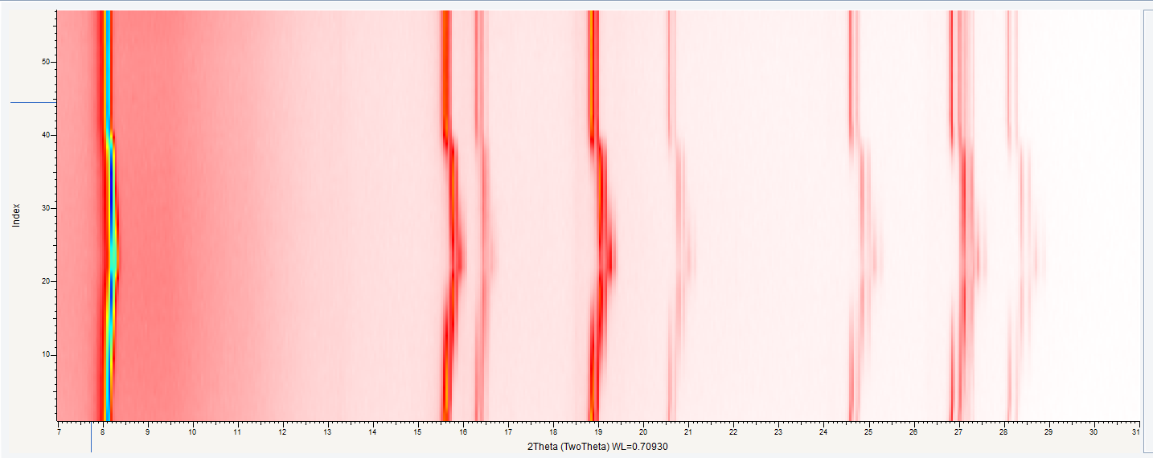
Figure 2: 2D plot diffractogram showing the structural change in LiMn_{1.5}Ni_{0.5}O₄ upon de-/intercalation of lithium. It is plotted with the time evolution on the y-axis and 2θ on the x-axis.
The set up was developed at the x-ray laboratory RECX, at the University of Oslo, Norway. The experiments were performed in transmission geometry with Mo radiation.
¹ Synthesis and characterization of novel cathode materials for Li batteries and their applications in Li batteries, PhD, P. Samarasingah

